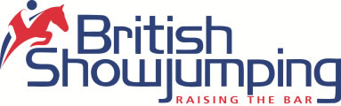 North Cumbria Area 14
Area Training
After another great days training with Robert Shields and requests for more training to be held the next area training has been booked with Robert and will be held on the area Show Field, Brougham, Penrith on Thursday 18th May. Training is again open to Juniors and seniors and costs £30.00 for ½ hour private lesson. There is an additional £5.00 charge for non BS members. Booking is now open and can be made via the Horse Monkey Website.
Unfortunately refunds can only be given if the space can be filled

Jonathan and Joanne Dixon have great success in Peelbergen
Well done to Jonathan and Joanne who have enjoyed a very successful two weeks competing at the CSI1* - CSI2* show in Peelbergen. There were many world class riders competing at the show including Scott Brash and Bertram Allen. Johnathan and Joanne’s results included the following
Week 1
Zaligra 4th and 5th in 1* 1.30m
Larino 2nd in 1* 1.20m
Camona 2 x 4th in 2* 1.35m
Gantico 6th 2* in 1.40m
Continio 5th in World Ranking Grand Prix

Week 2
Zaligra 4th in 1* 1.30m
Camona 2 x 2nd in 1* 1.30m
Gantico 4th & 1st in 2* 1.35m
Continio 2nd in 2* 1.45m and 11th in World Ranking Grand Prix

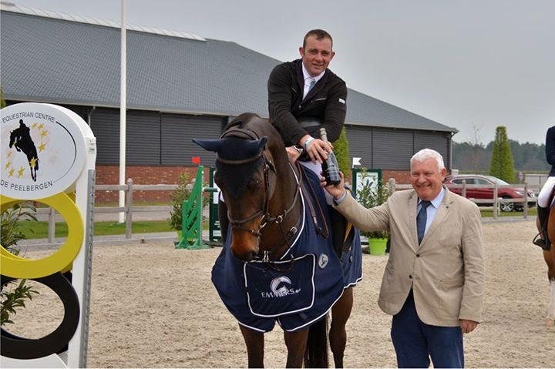
Jonathan and Gantico receiving their prize for winning the 2* 1.35m

Atlanta Vailionis and Vimy Hero on winning form in Cavan.
Well done to Atlanta riding Vimy Hero who won the 1.10m Grand Prix in Cavan on Sunday. This combination was also placed 12th out of 120 in the 148 class.

Alex McHattie and Sonata win in Lier
Well done to Alex McHattie riding George and Beryl Haslam’s Sonata winning the CSIJ 1.25m in Lier. This followed on from their 2nd place the previous week in the 1.25m in Bonheiden. Alex also had success with George and Beryl’s Rhodanites Rowenberry in Lier being placed 5th in the 1.35m speed and 4th in 1.30m.

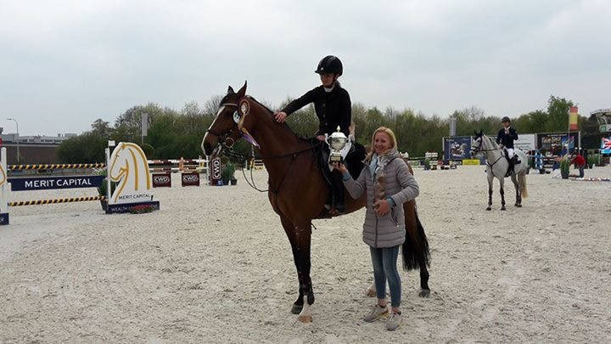
Alex and Sonata receiving their prize for winning the CSIJ 1.25M

Junior Academy
The launch of the Junior academy on Tuesday proved very popular and we have received some super feedback thank you. Planning for the next junior academy has already started and details will be announced as soon as we have them.

Show Sponsors
Thank you to the following companies who are very kindly sponsoring at our two-day area show in May. If you would like to sponsor, please contact any committee member or call the area phone on 07468 111787.





Douglas Duffin

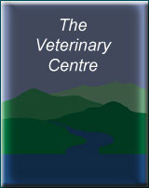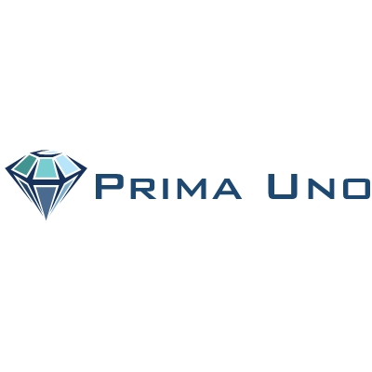
Frame, Swift & Partners

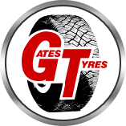
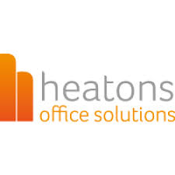

www.britishshowjumping.co.uk/area/North-Cumbria
Don’t forget to check out our area face book page Area 14 North Cumbria British Show jumping

